|  |
| --- |
|  |
| Stride User Manual |
|  |
|  |
|  |
|  |

Table of Content

Workflow related Tasks 4

A. Create and View Workflows 4

B. Create and View Projects 7

C. Workflow and Project Mapping 9

Workflow Tasks and It’s Features 12

Standalone Tasks 14

Starting and Stopping a Task 16

Status and Priority 17

Subtasks and Weightages 20

Views 23

A. My Assigned Tasks 23

B. Created By Me 24

C. My Owned Tasks 25

Reports and Dashboards 26

|  |  |  |  |  |
| --- | --- | --- | --- | --- |
| **Prepared By** | **Reviewed By** | **Date** | **Approved By** | **Remarks** |
| Rathin Das |  |  |  |  |

|  |  |  |  |  |
| --- | --- | --- | --- | --- |
| **Version No** | **Remarks** | **Date Changed** | **Approved / Rejected By** | **Remarks** |
| 1 |  |  |  |  |

## Workflow related Tasks

### Create and View Workflows

Enter the URL: [**https://stride.jmfl.com**](https://stride.jmfl.com). The following screen will appear.

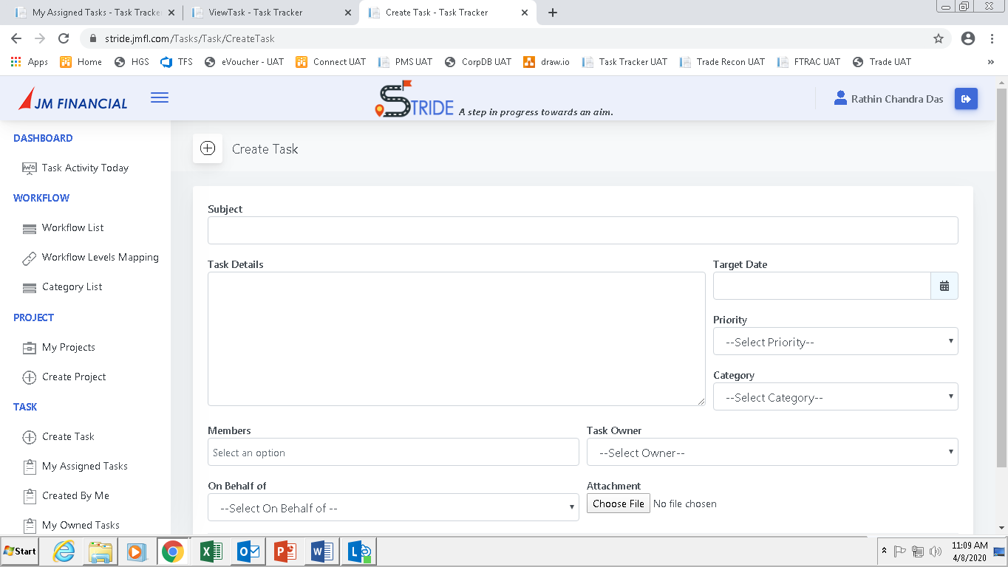

Click on **Workflow List**. The following screen will appear.

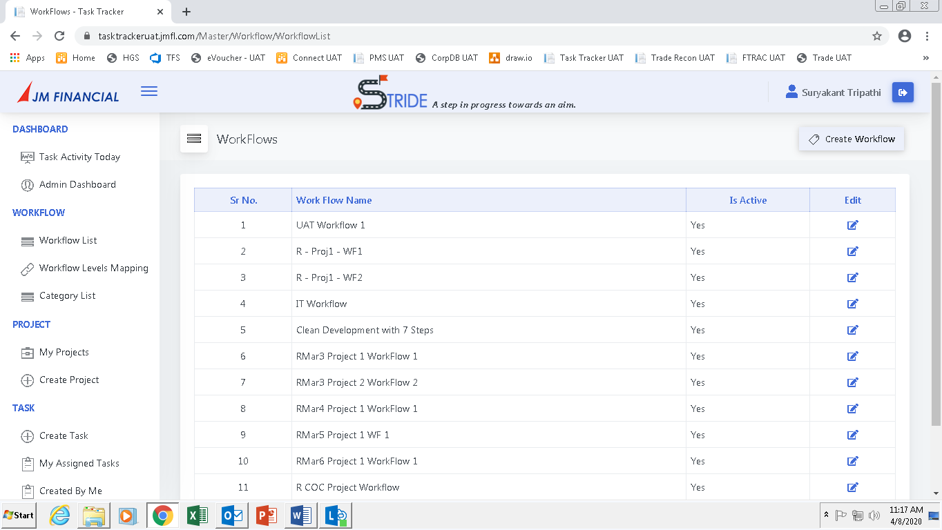

The list of Workflows can be viewed here. Click on **Create Workflow**. The following screen will appear.

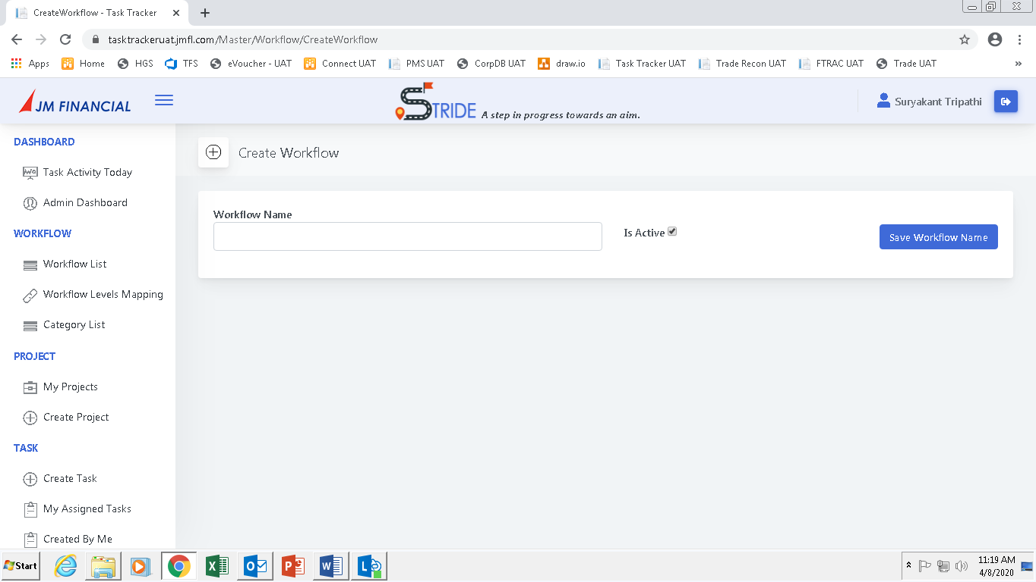

Enter the **Workflow Name** and click on **Save Workflow Name**. The following screen will appear.

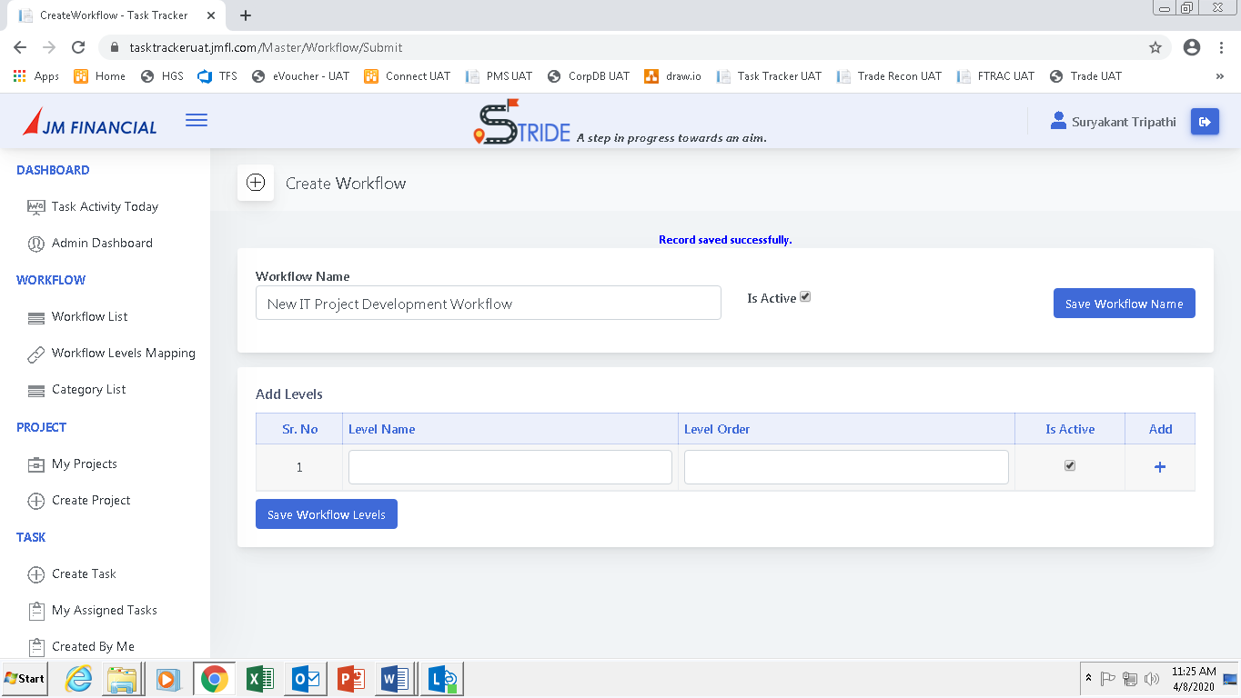

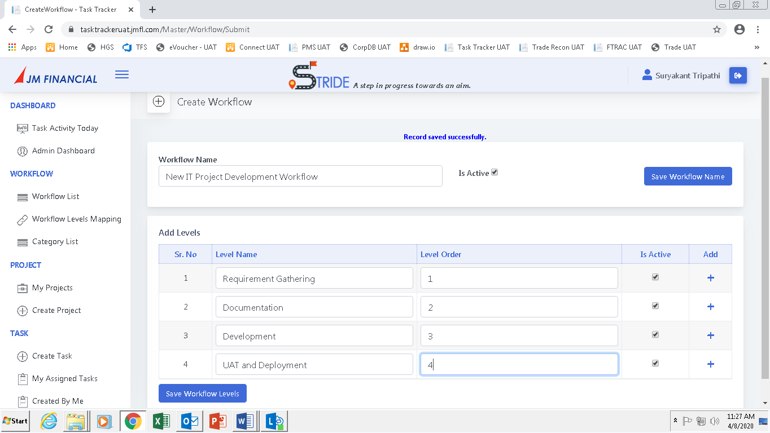

Enter the workflow levels **as shown**. The number of rows can be increased by clicking on the (**+**) button. After entering the details click on **Save Workflow Levels**.

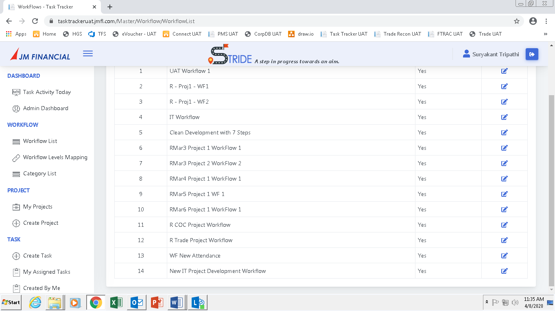

The **new workflow** can be seen in the **Workflow List**. Click **Edit** button to edit the workflow.

### Create and View Projects

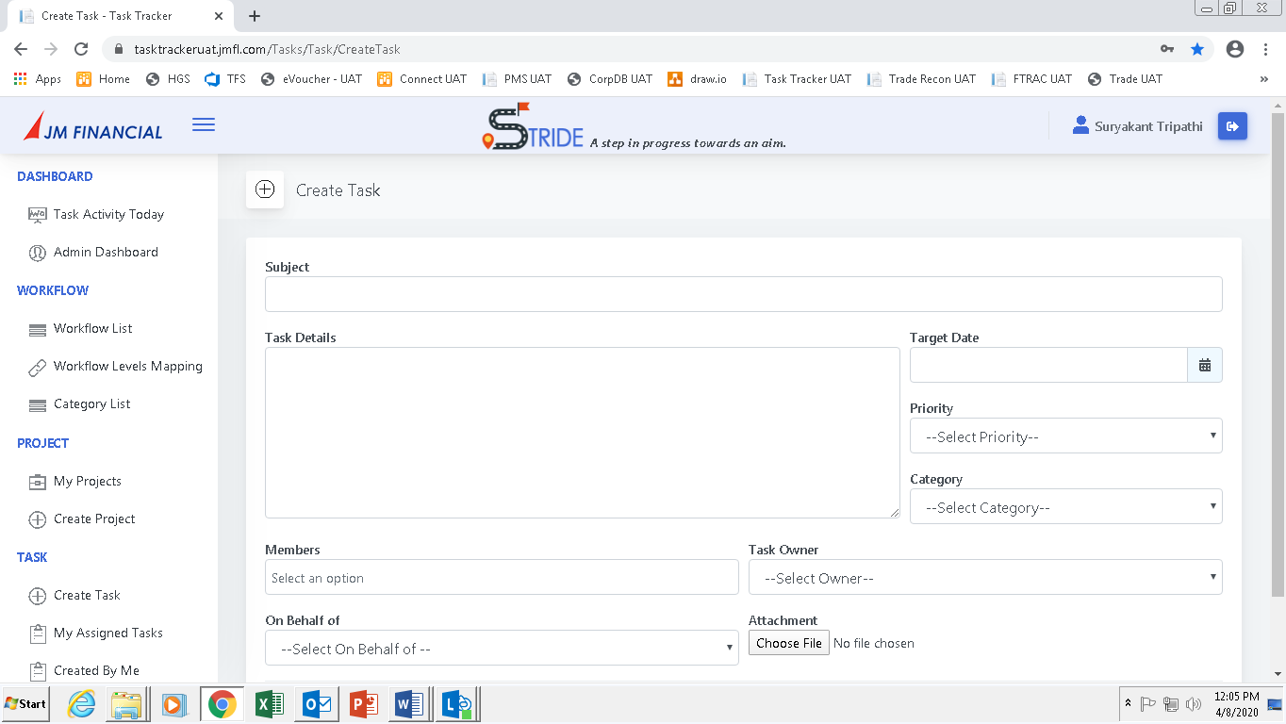

Click on **Create Project**. The following screen will appear.

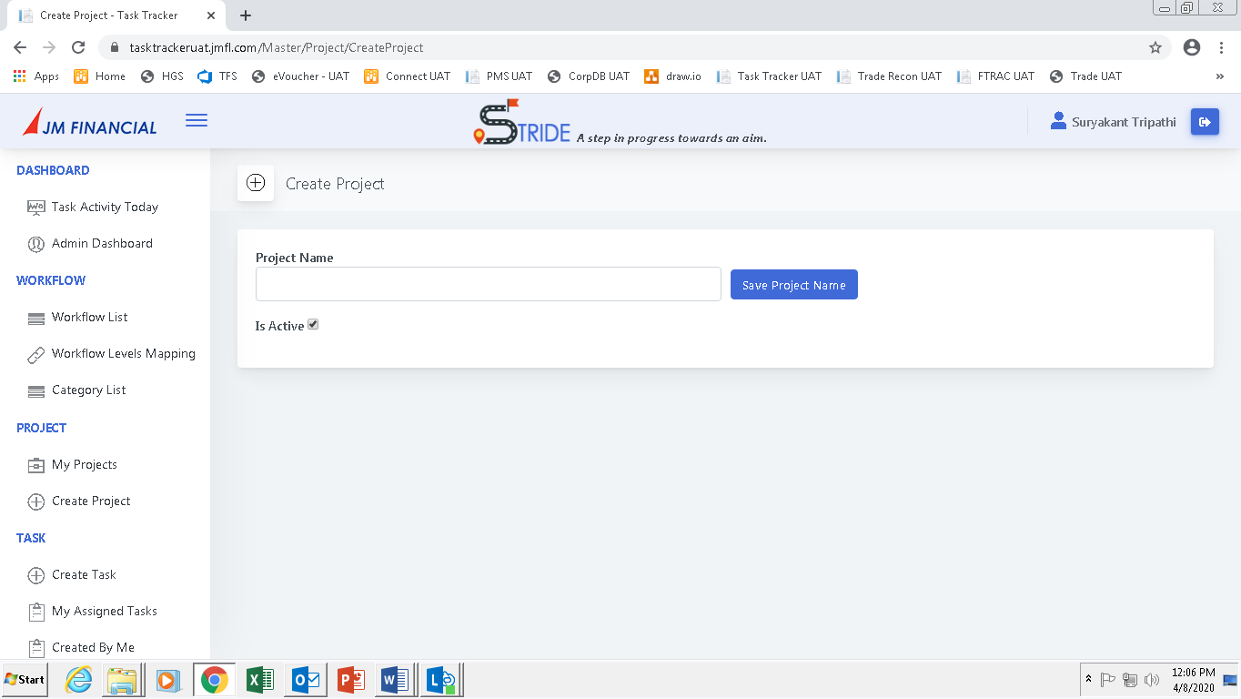

Enter the **Project Name** and click on **Save Project Name**. The following screen will appear.

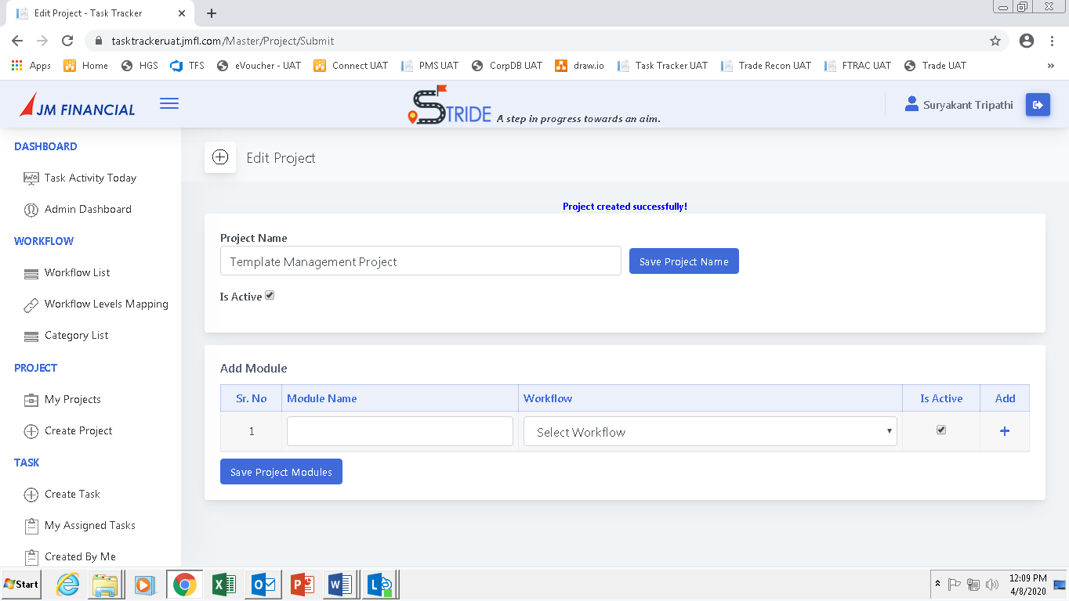

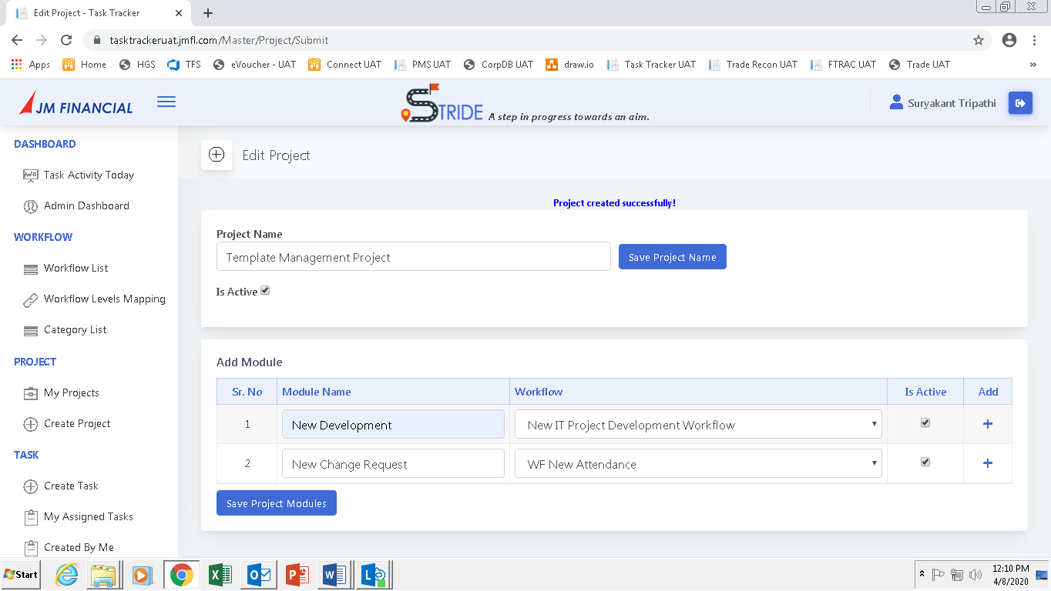

Enter the **Module Names**, select the **Workflows** (previously created) and click on **Save Project Modules**. The number of rows can be increased by clicking on the (+) button.

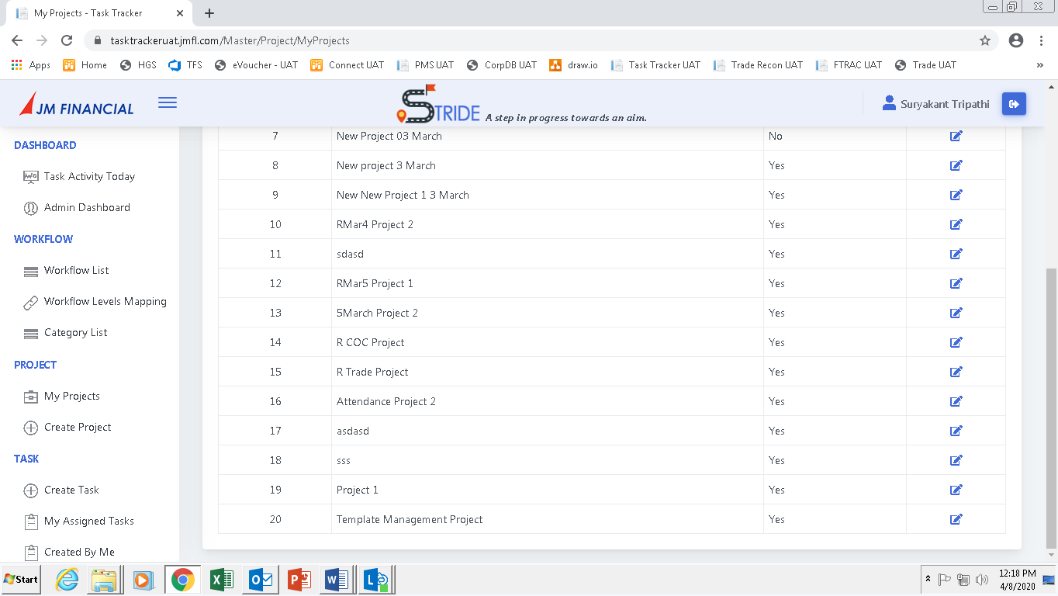

The **new project** can be seen after clicking on the **My Projects** button. Click **Edit** button to edit the project.

### Workflow and Project Mapping

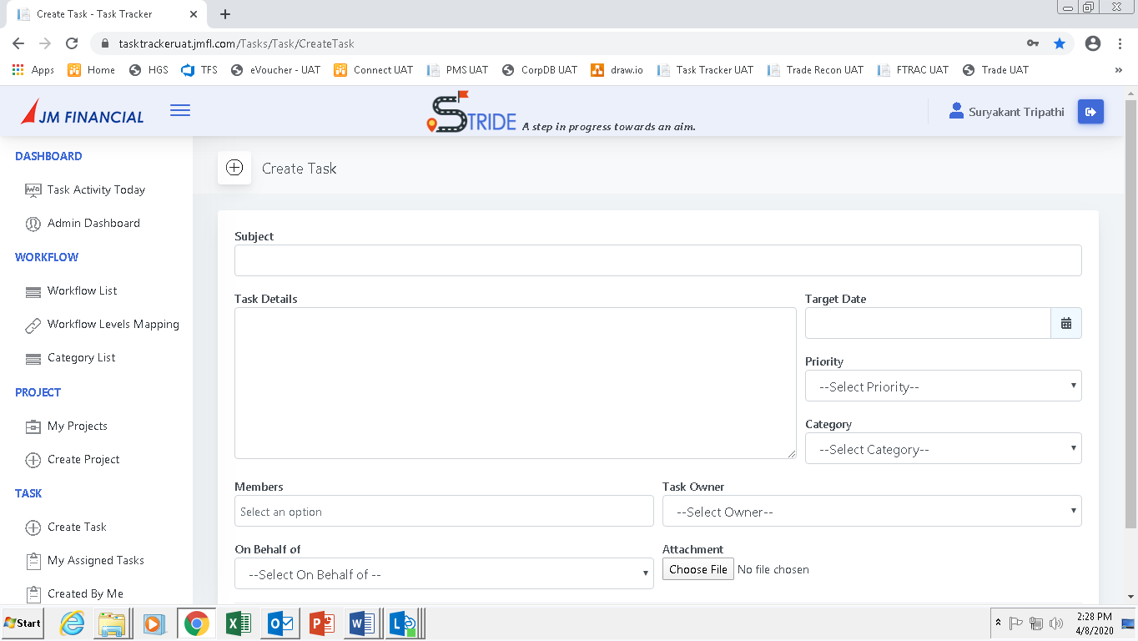

Click on **Workflow Levels Mapping**. The following screen will appear.

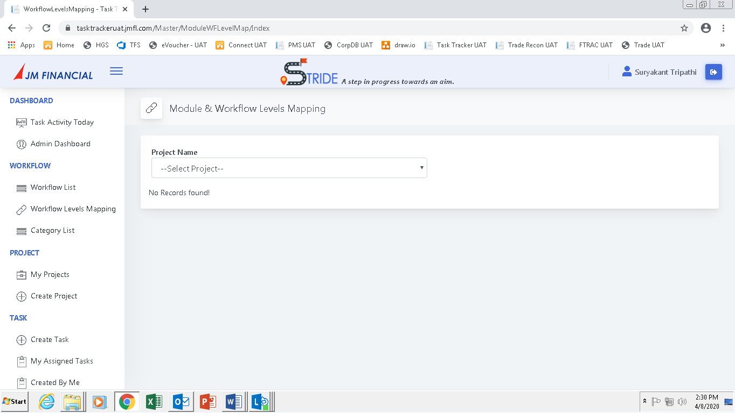

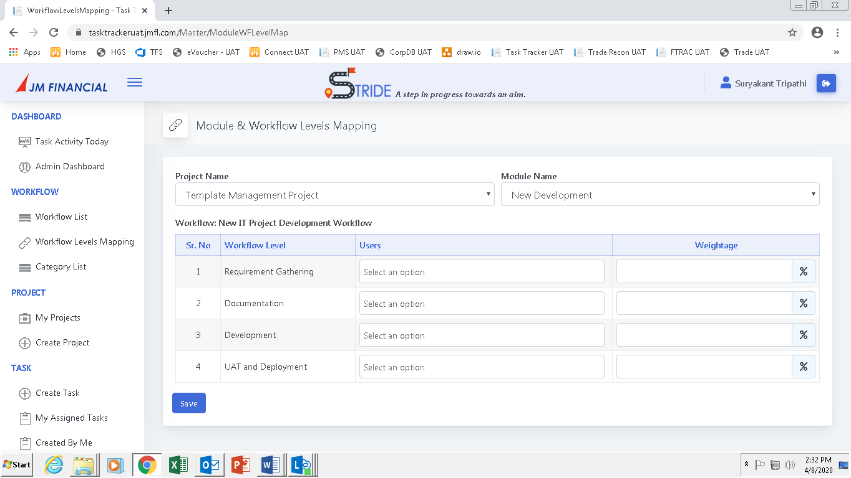

Select the **Project** and the **Module**. The **Workflow Levels** will populate automatically.

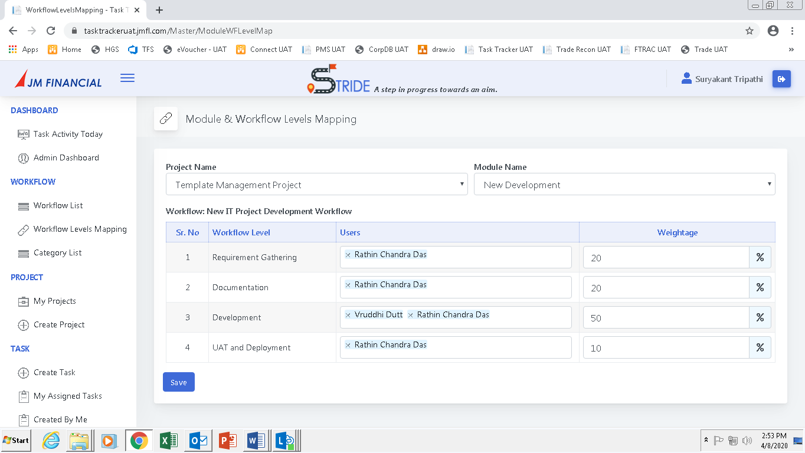

Enter the **user details**, add **weightage** and click on **Save**.

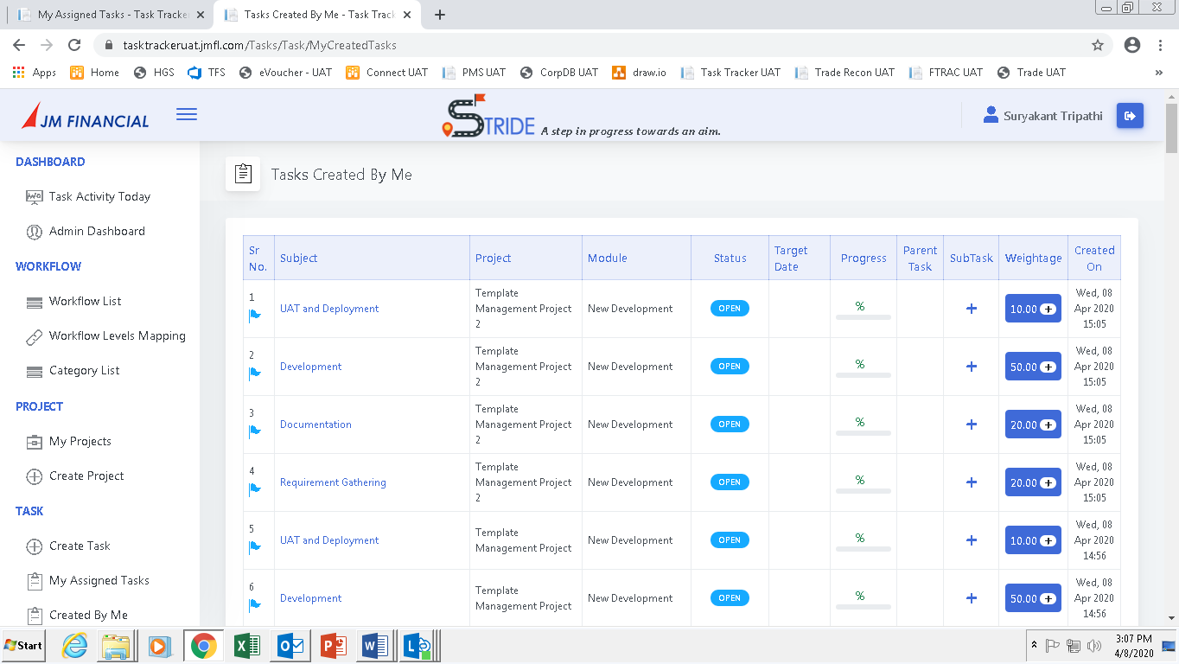

Each Workflow level will now convert into a **single task**. Every task will be related to a Project and a Module. These tasks can be seen in the views “**My Assigned Tasks**” and “**Created By Me**”.

## Workflow Tasks and It’s Features

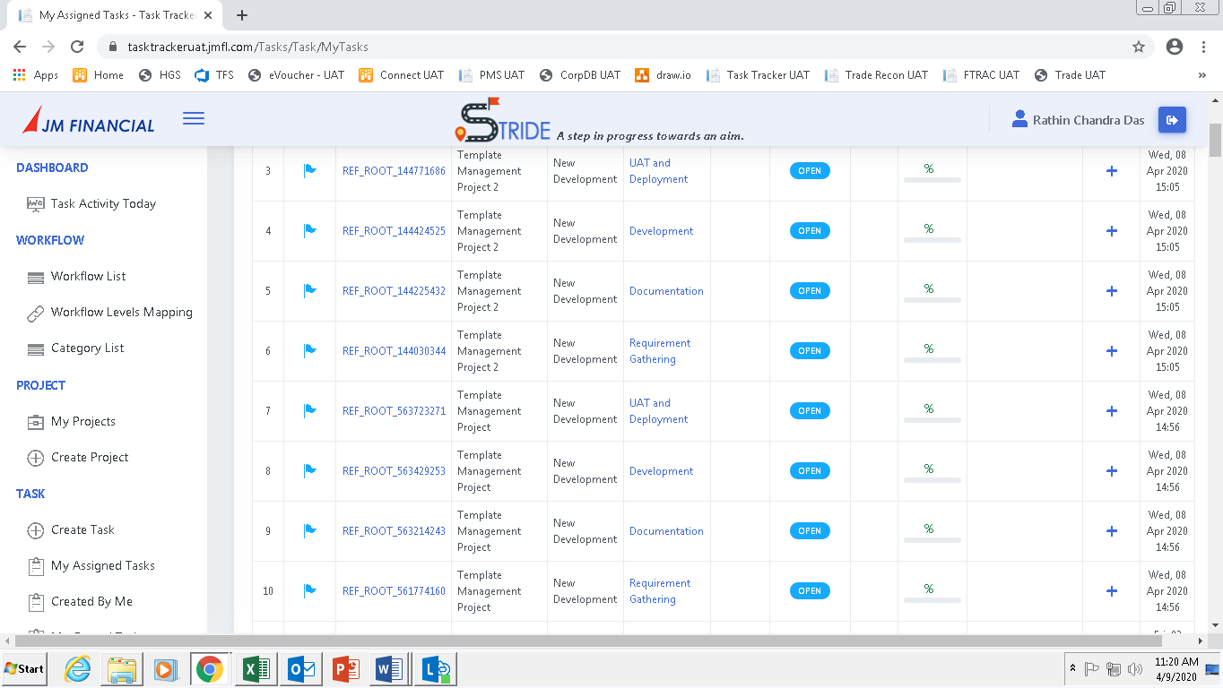

Click on any of the **tasks**. The following screen will appear.

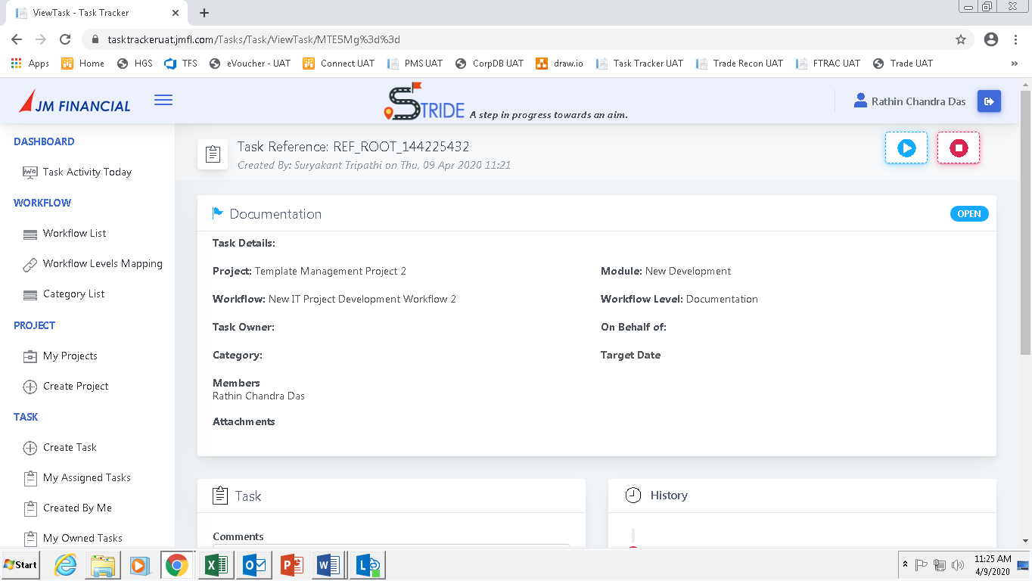

The **Project, Module and Workflow** details can be seen here.

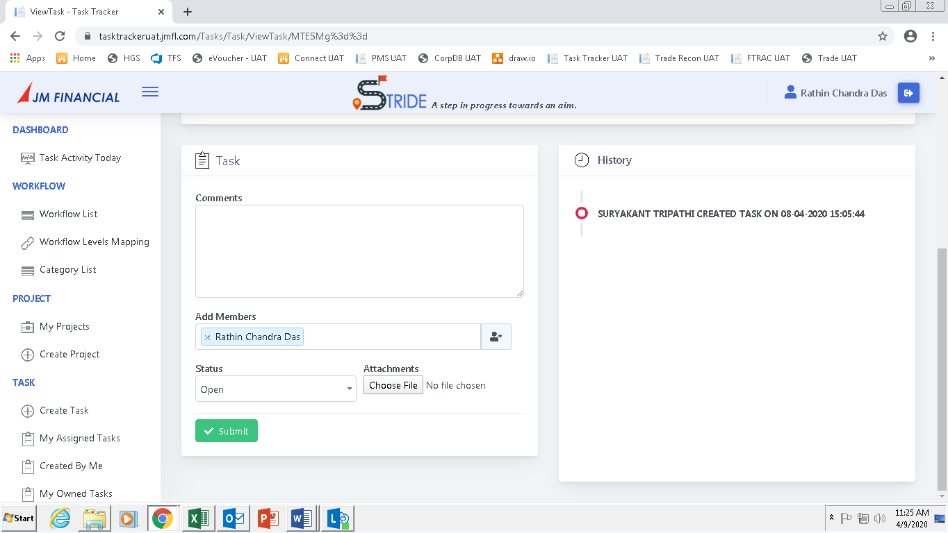

The user will be able to:

1. Add Comments
2. Add and Remove Members
3. Change the status
4. Upload files

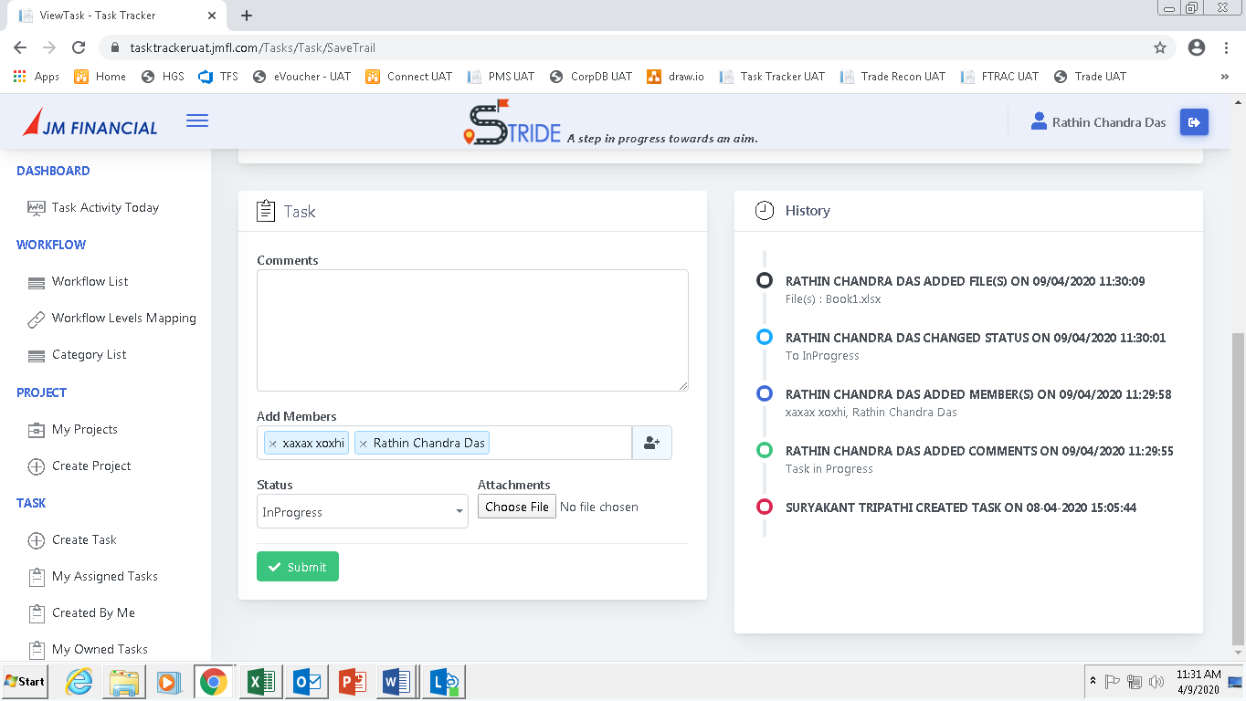

Any changes made to the task can be seen in the **History** section.

## Standalone Tasks

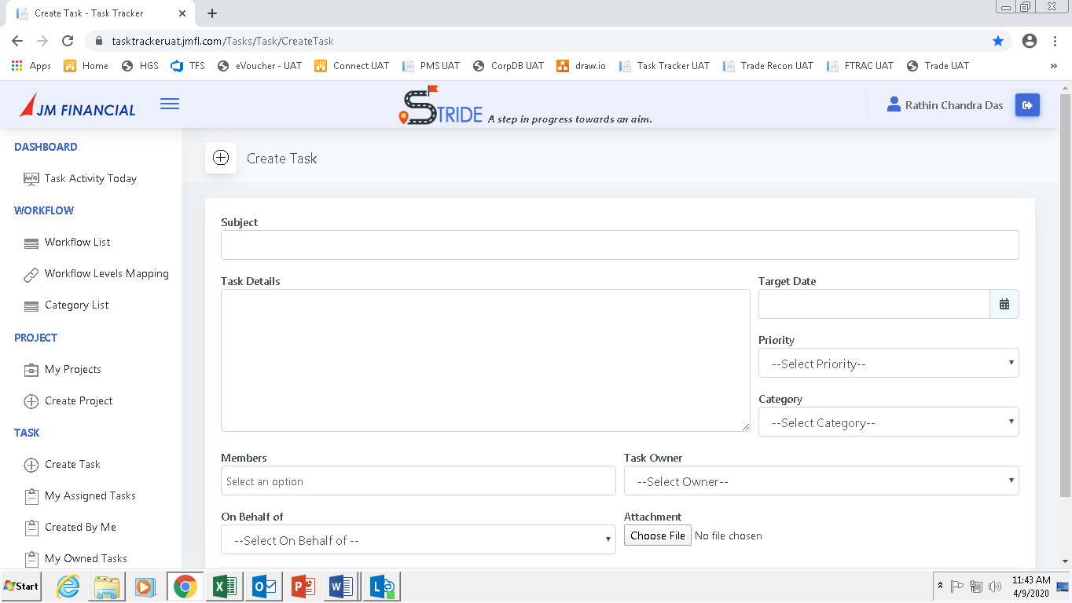

Click on **Create Task**. The following screen will appear.

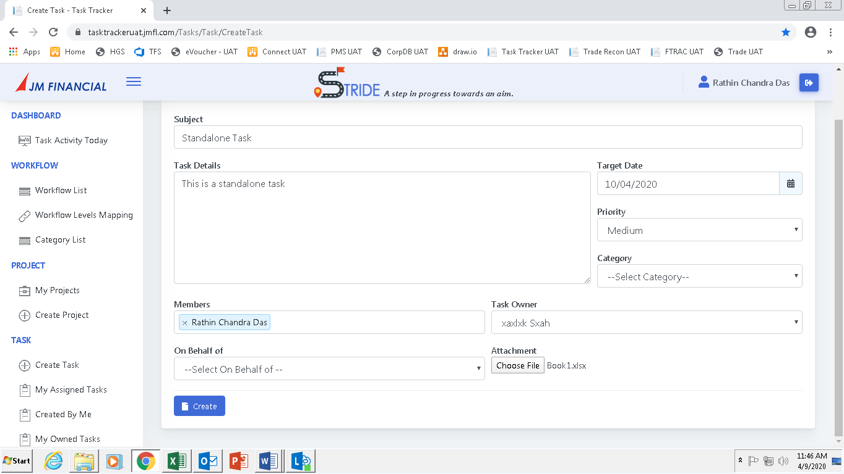

Fill the task details and click on **Create**.

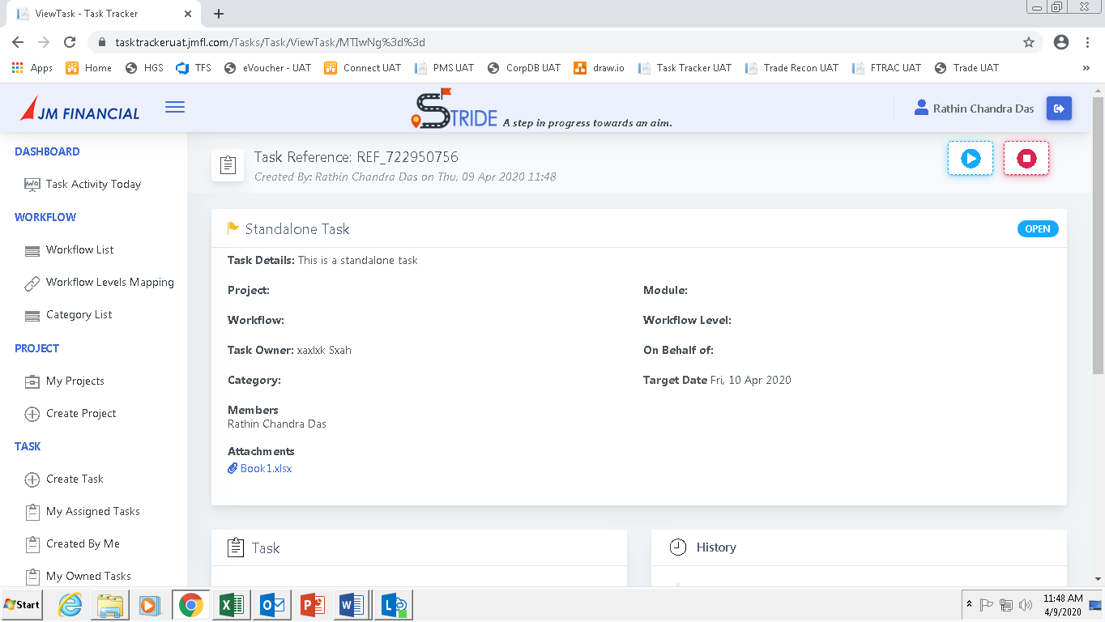

The task will be created in the system. These tasks are not related to any projects but are standalone ones.

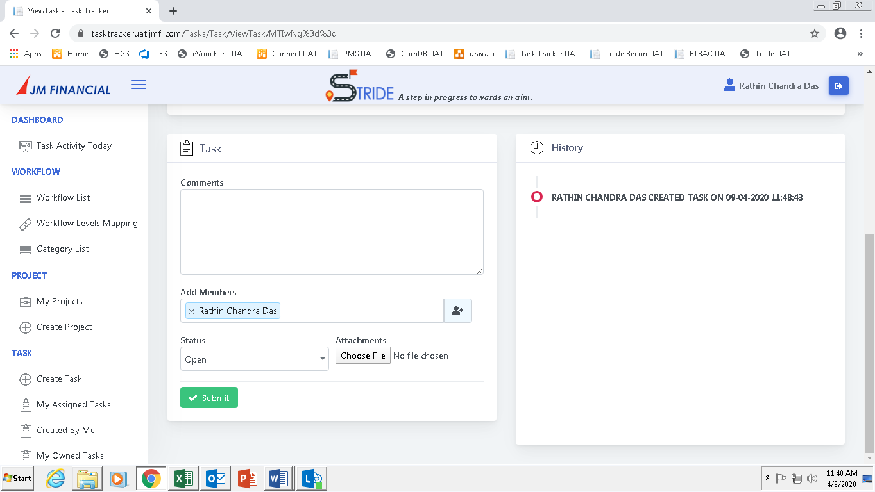

The user will be able to:

1. Add Comments
2. Add and Remove Members
3. Change the status
4. Upload files



Any changes made to the task can be seen in the **History** section.

## Starting and Stopping a Task

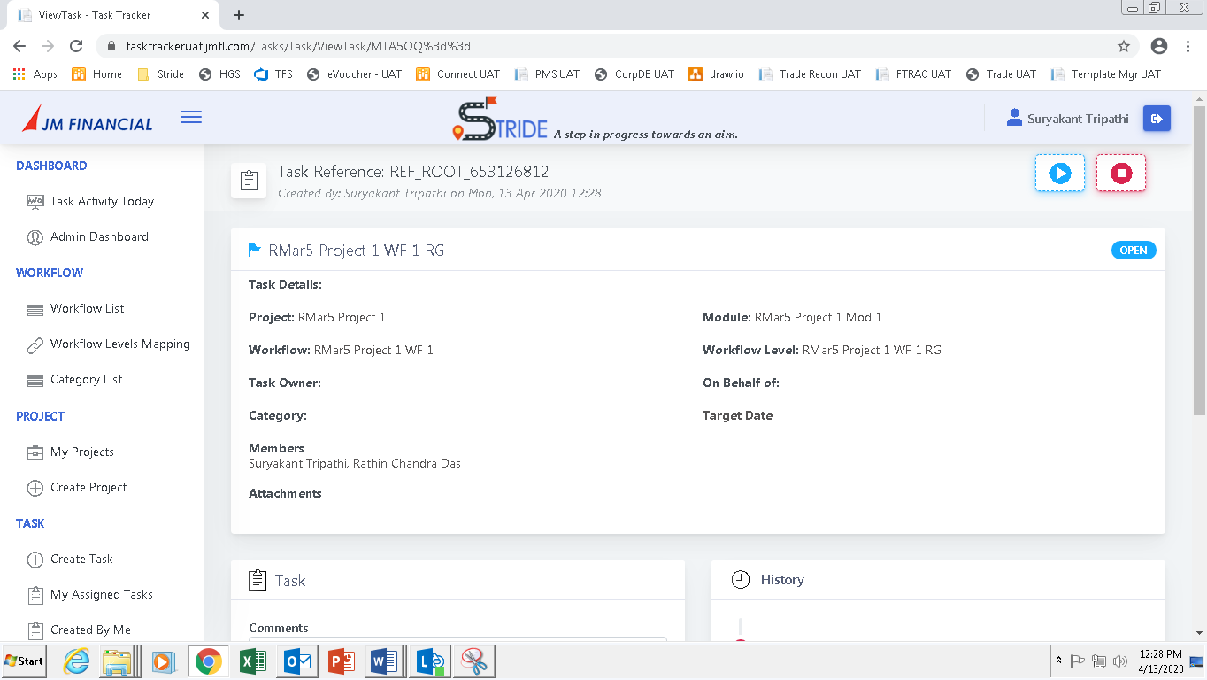

Every task will have a **Start** and **Stop** buttons as shown.

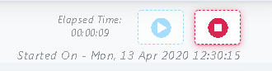

On clicking the Start button the countdown timer will start. Before starting a task the employee will have to click on the Start button.

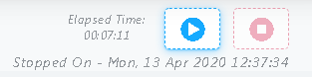

On clicking the Stop button the countdown timer will stop. After stopping a task the employee will have to click on the Stop button.

## Status and Priority

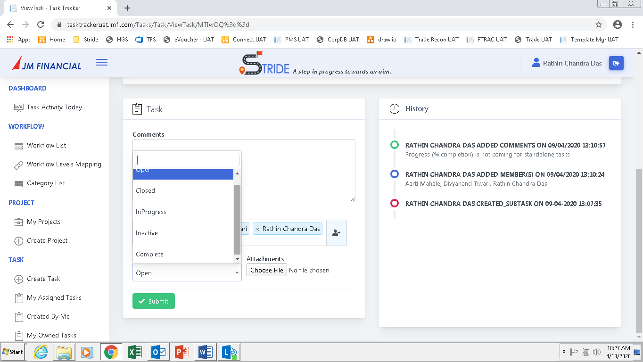

Task Status can be changed by selecting the **dropdown field**.

The Status applicable are:

1. Open
2. In Progress
3. Complete

Task in Open status

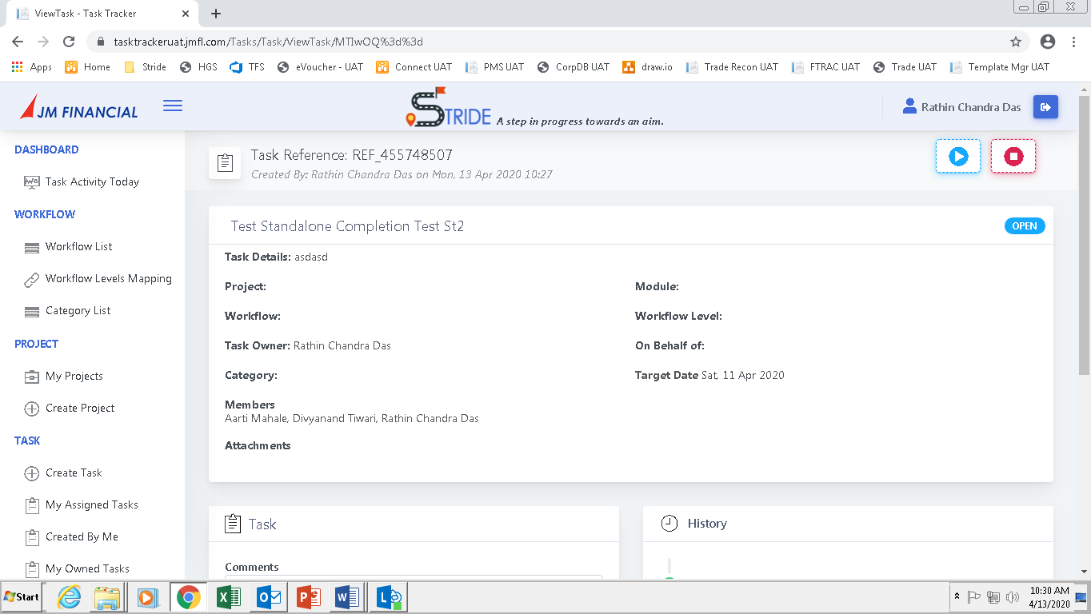

Tasks in In Progress status

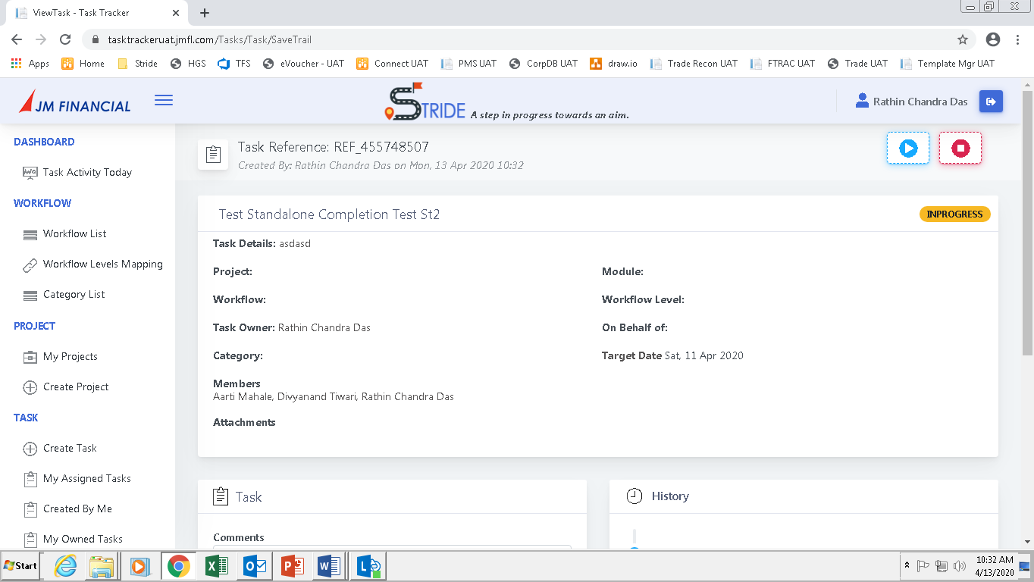

Tasks in Complete Status. No further changes can be made to the after the status is changed to complete.

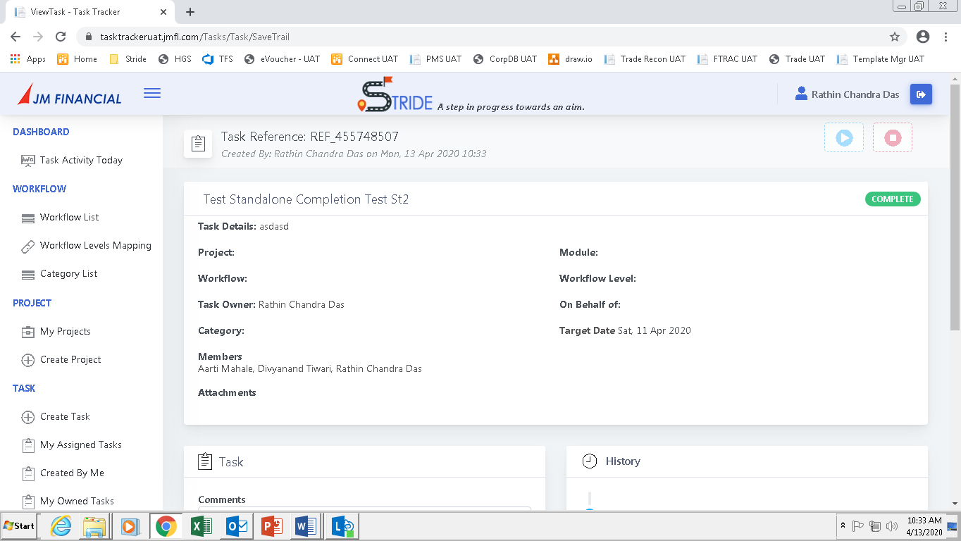

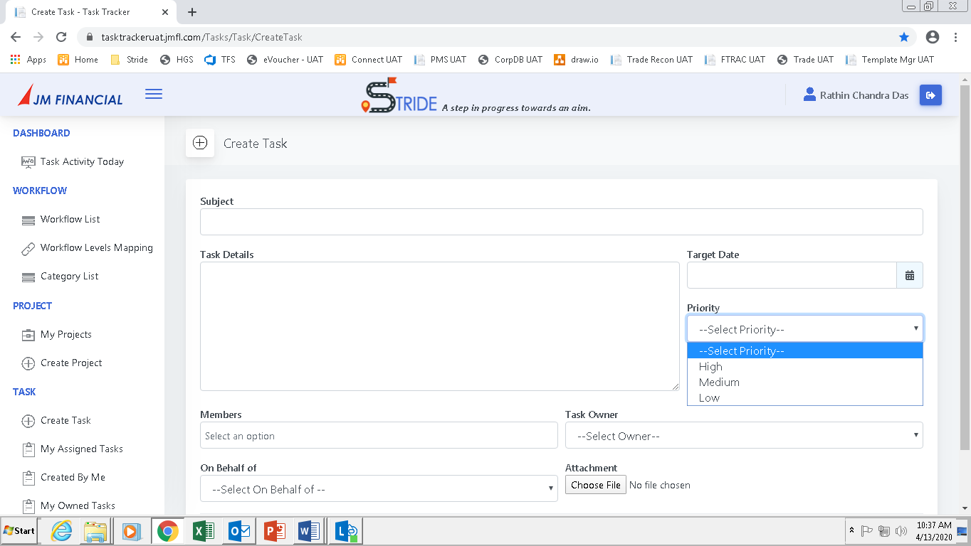

Task priority can be set from the **Priority** field.

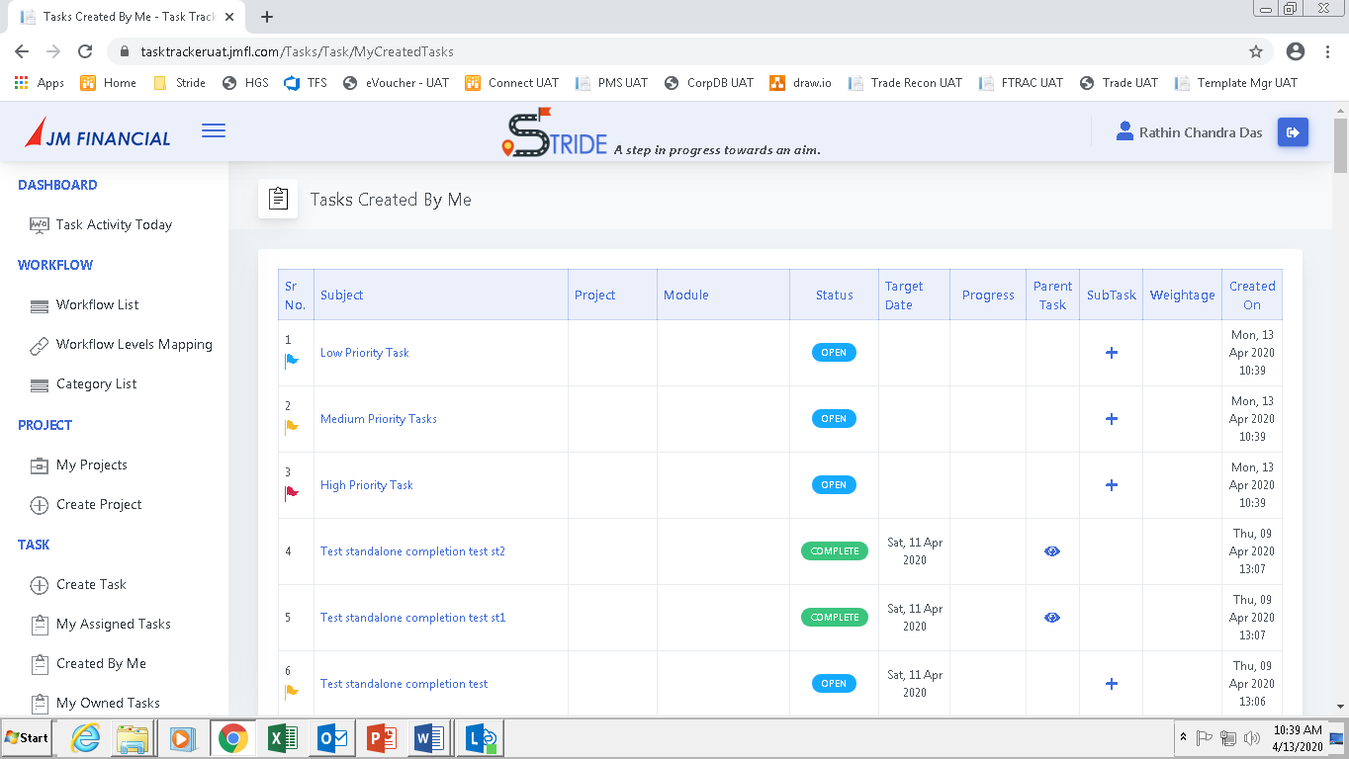

The tasks based on priority are marked with coloured flags as shown below.

1. High Priority - 
2. Medium Priority - 
3. Low Priority - 

## Subtasks and Weightages

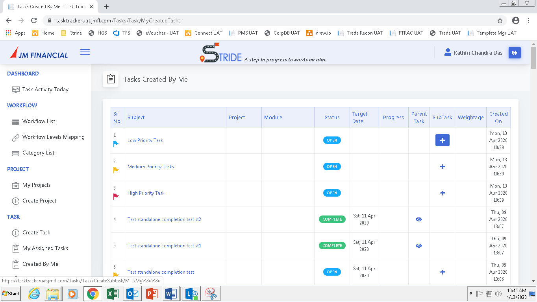

Click on the (**+**) button to create a sub task. The following screen will appear.

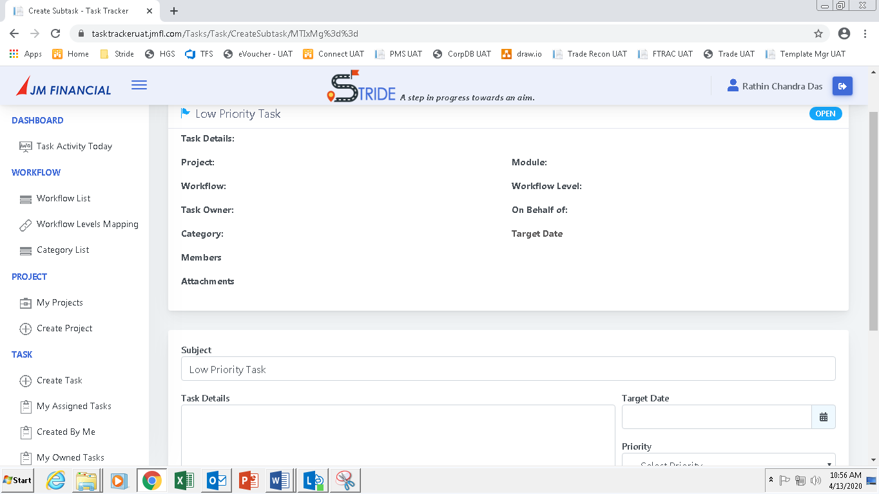

The parent task will be seen at the **top** and a form **below** will be available to add the subtask.

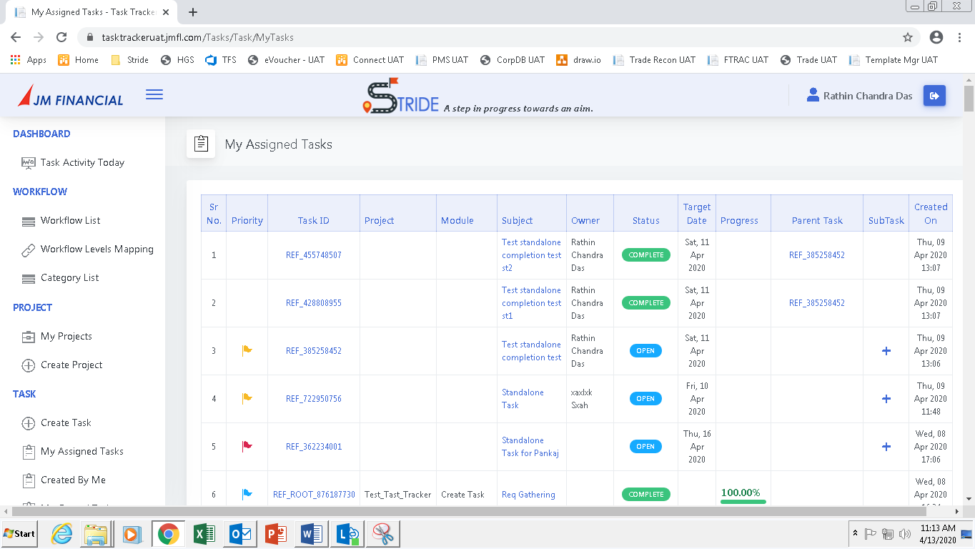

The parent task and sub task relationship can be seen as above.

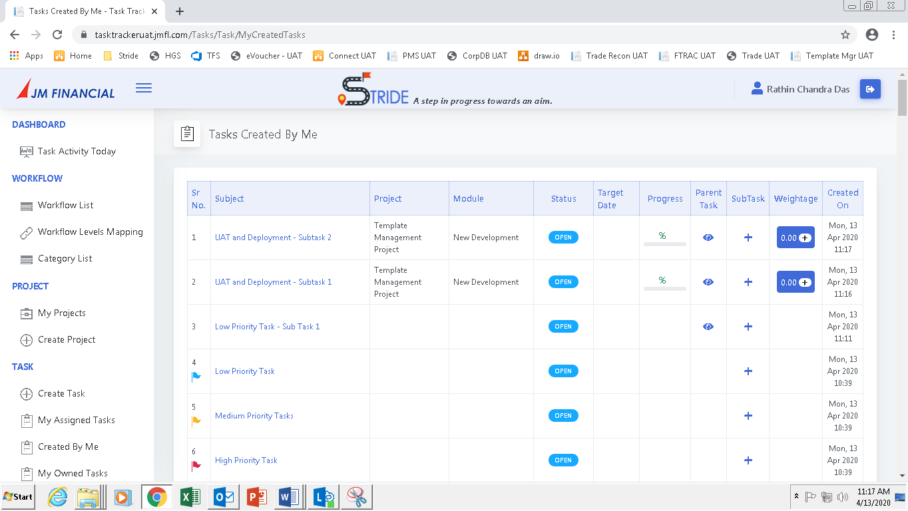

After the subtasks are created, go to the view **Created By Me** and click on **Weightage.** The following screen will appear.

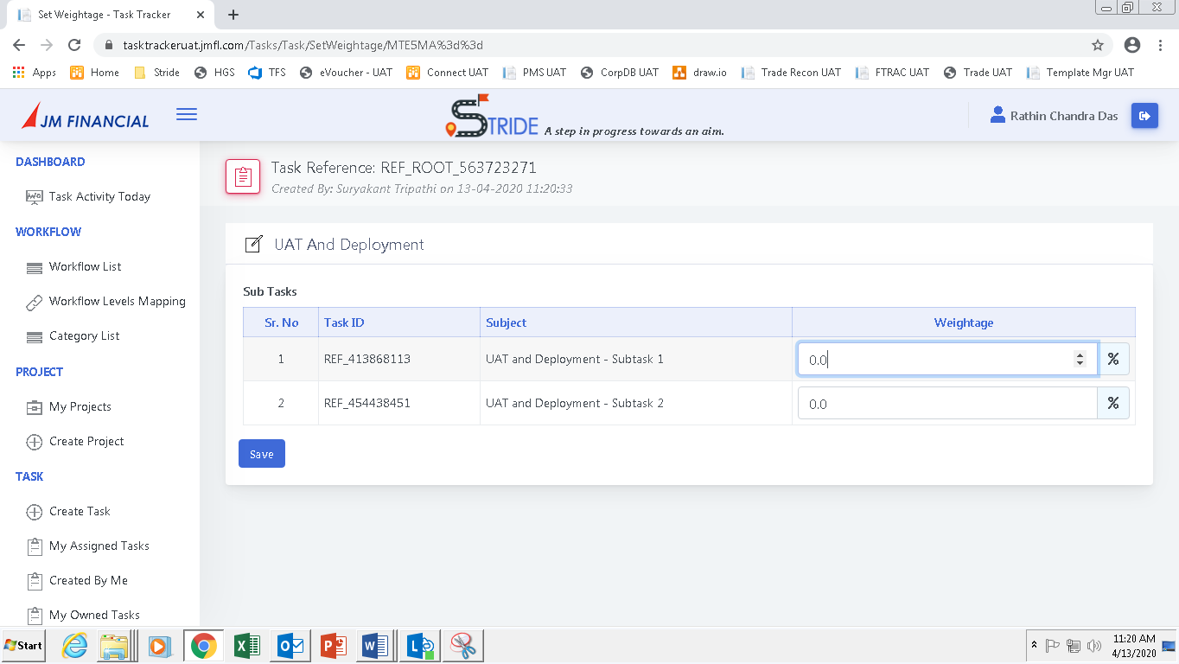

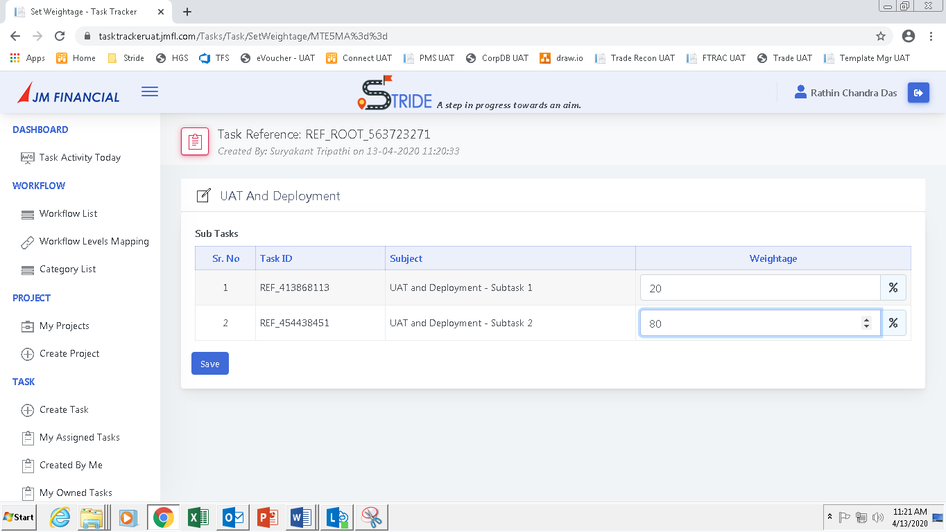

Give weightage % to the subtasks and click on Save.

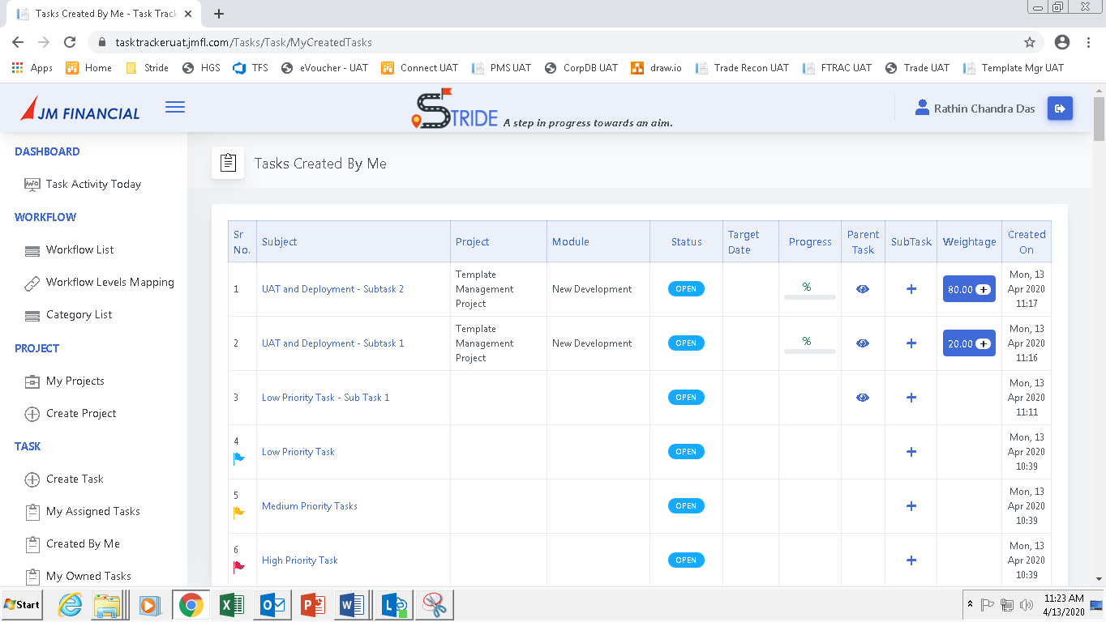

The weightage can be seen in the sub tasks.



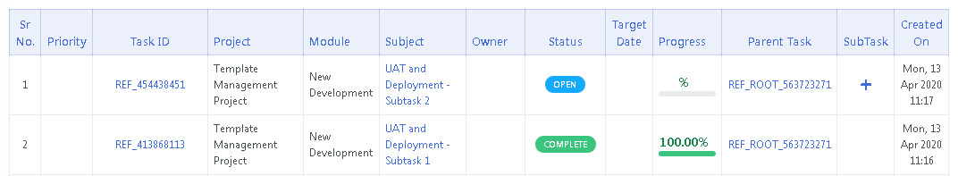

Mark any of the subtask as complete. The **progress** of the subtask will show 100%. The **progress of the parent task** will be equal to the weightage given to the subtask that was completed.

## Views

Three types of views are available

1. My Assigned Tasks
2. Created By Me
3. My Owned Tasks

### My Assigned Tasks

The tasks assigned to a user are listed here.

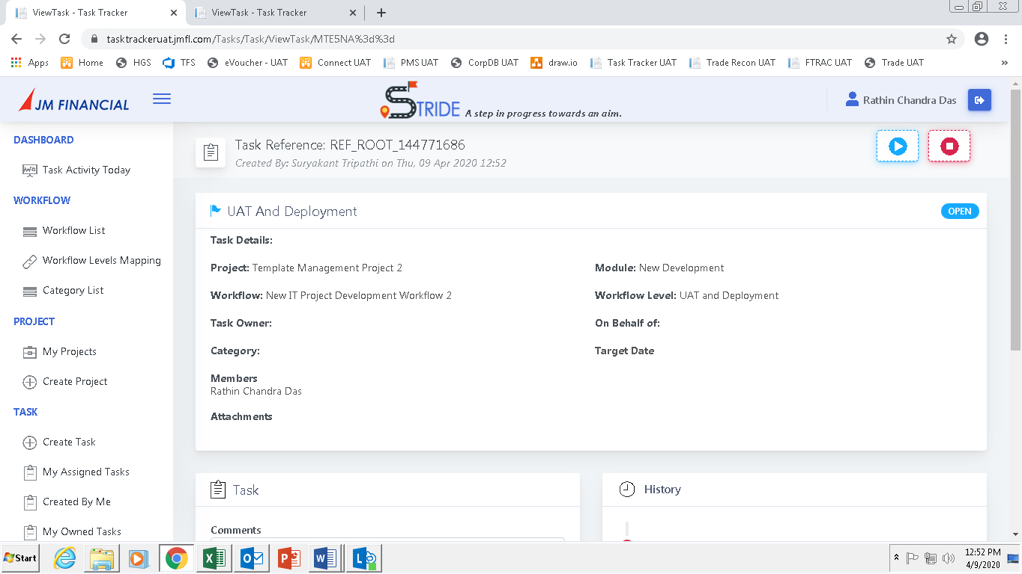

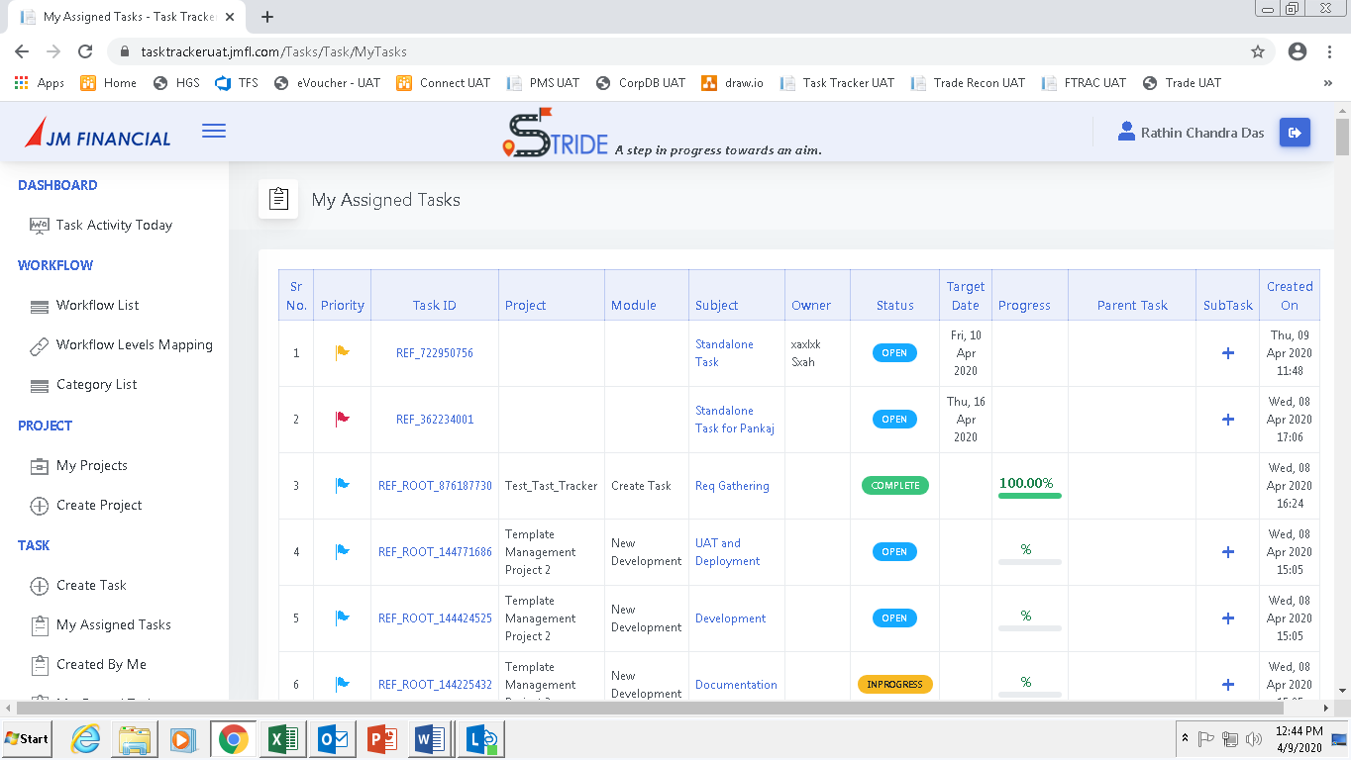

### Created By Me

The tasks created by a user are listed here.

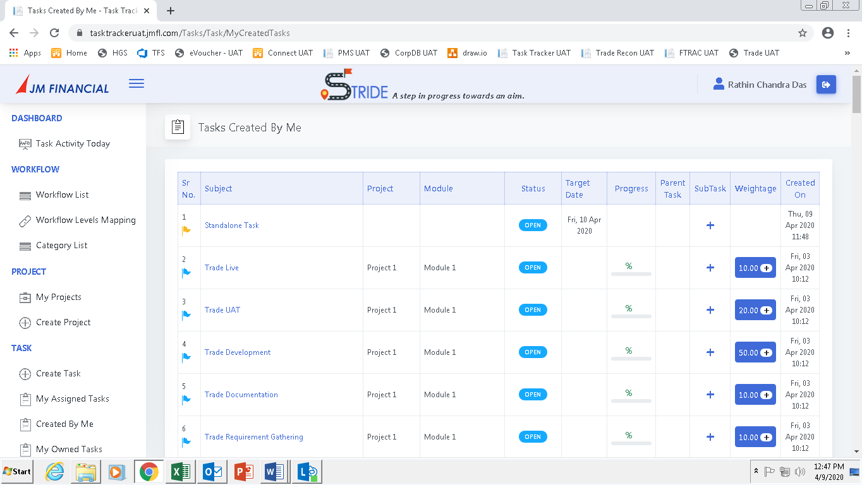

### My Owned Tasks

The tasks owned by a user are listed here.

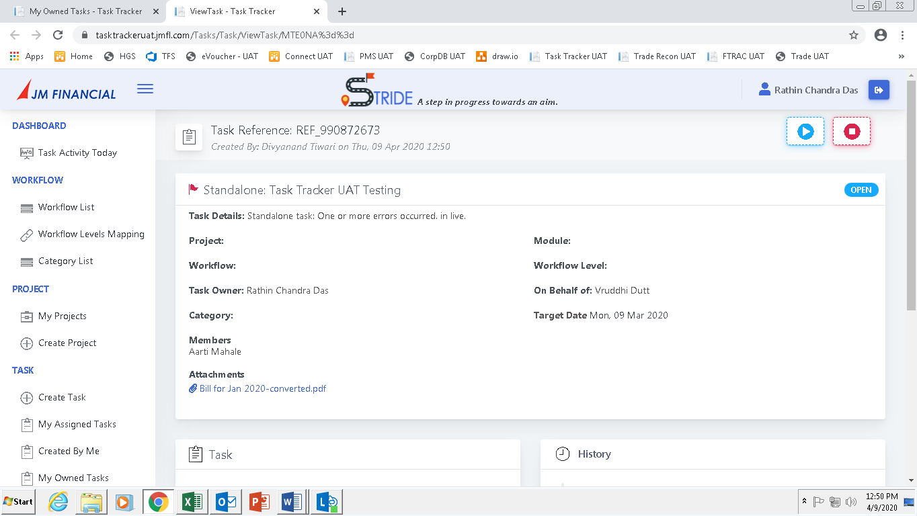

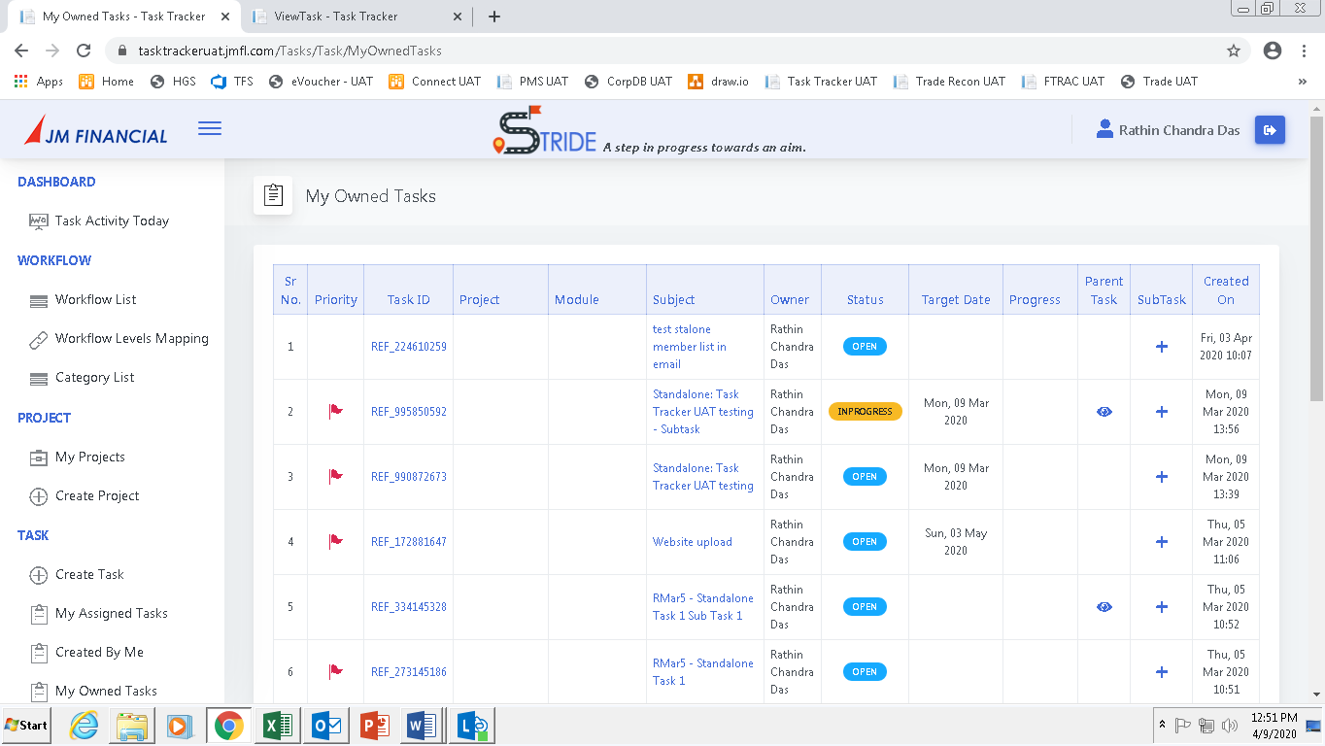

## Reports and Dashboards

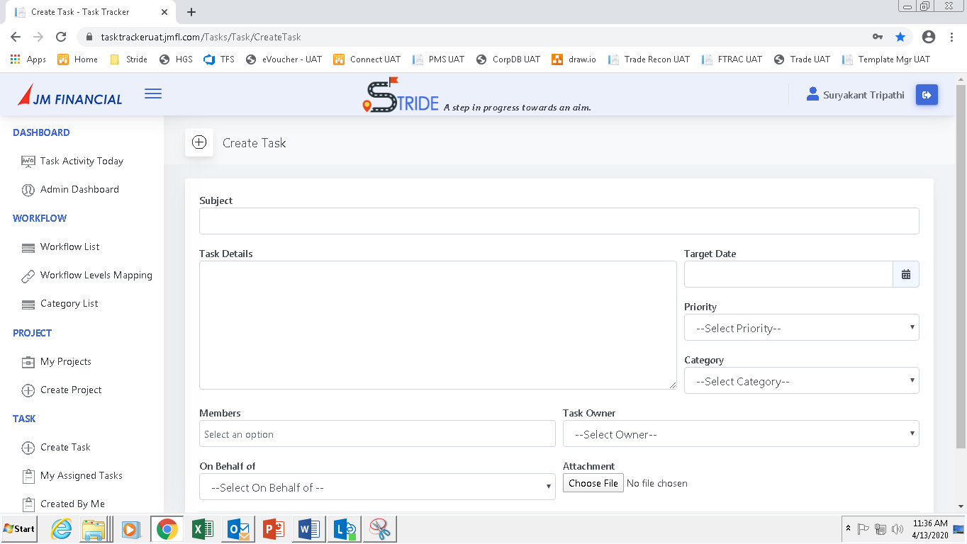

Click on **Task Activity Today**. The following screen will appear.

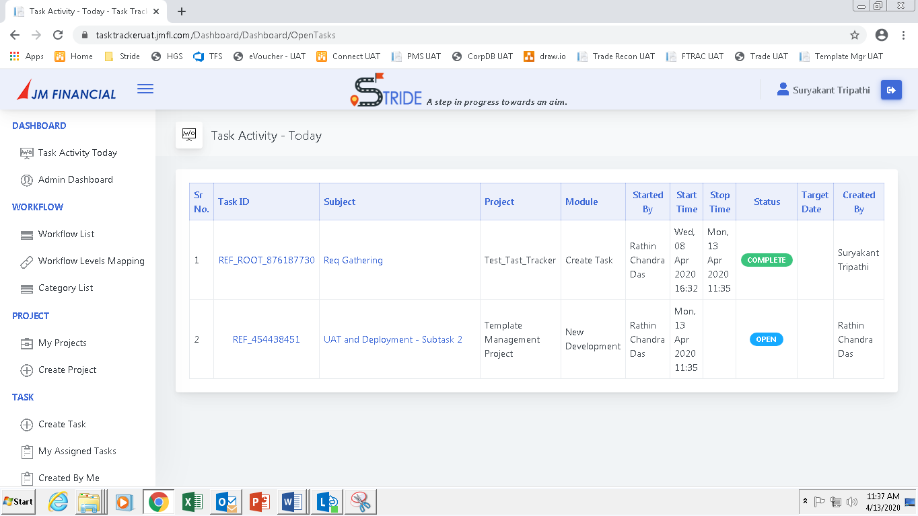

All the tasks undertaken by various employees/users will be displayed.



Click on **Admin Dashboard** (Available to Senior Management only). The following screen will appear

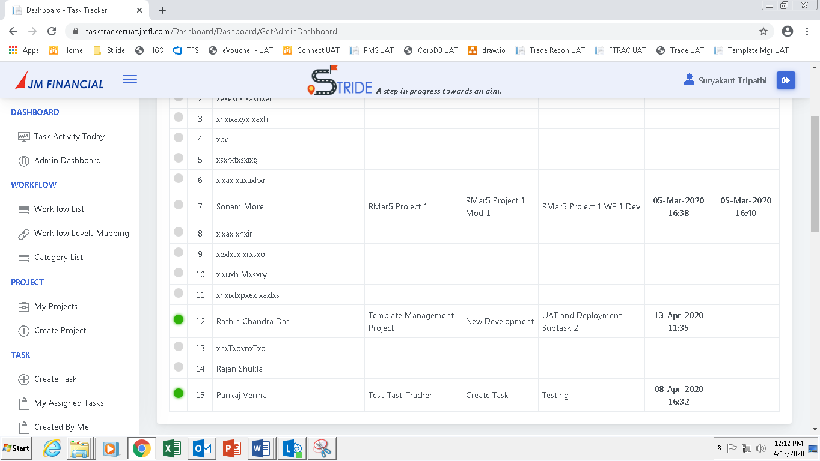

The employees who are **currently working** on a particular task will have a green indicator against them. The indicator will turn green only when the employee/user click on the start button against a task. The indicator will turn grey when the employee/user click on the stop button against a task.

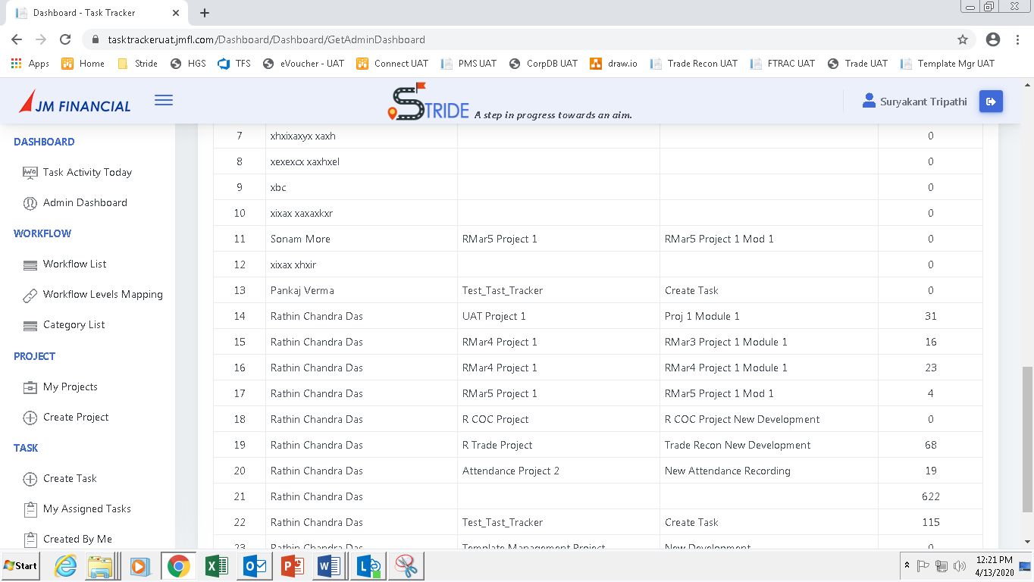

On scrolling down further, the team activity report will be displayed. This report gives a project wise and user wise effort for a set of users or teams.